**Supplementary Figure**

**Supplementary Figure 1. Biplot from Principal Component Analysis on the combined genotype data of 1000Genome reference panel1 and the ABCD study participants (colored blue).** Super-populations are defined broadly as: AFR African, AMR admixed American, EAS East Asian, EUR European, SAS South Asian. To facilitate the understanding of genetic ancestry of the study participants, PCA was performed with 1000Genome phase3 reference panel and plotted with the first two principal components. Since ABCD participants reside on a continuum of genetic ancestry as American population (AMR), rather than distinct population groups, and none of them belongs to either African (AFR) or East Asian (EAS) populations, we did not exclude any genetic outliers based on the plot. 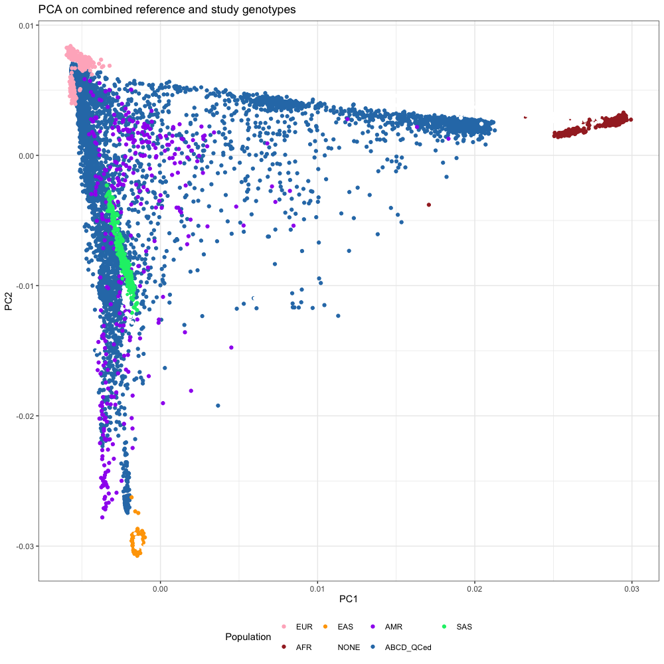

**Supplementary Figure 2.** **The result of generalized linear models between brain connectome and CP GPS (a, b), EA GPS (c, d).** The dotted line indicates the significance threshold (*PFWE* = 0.05).

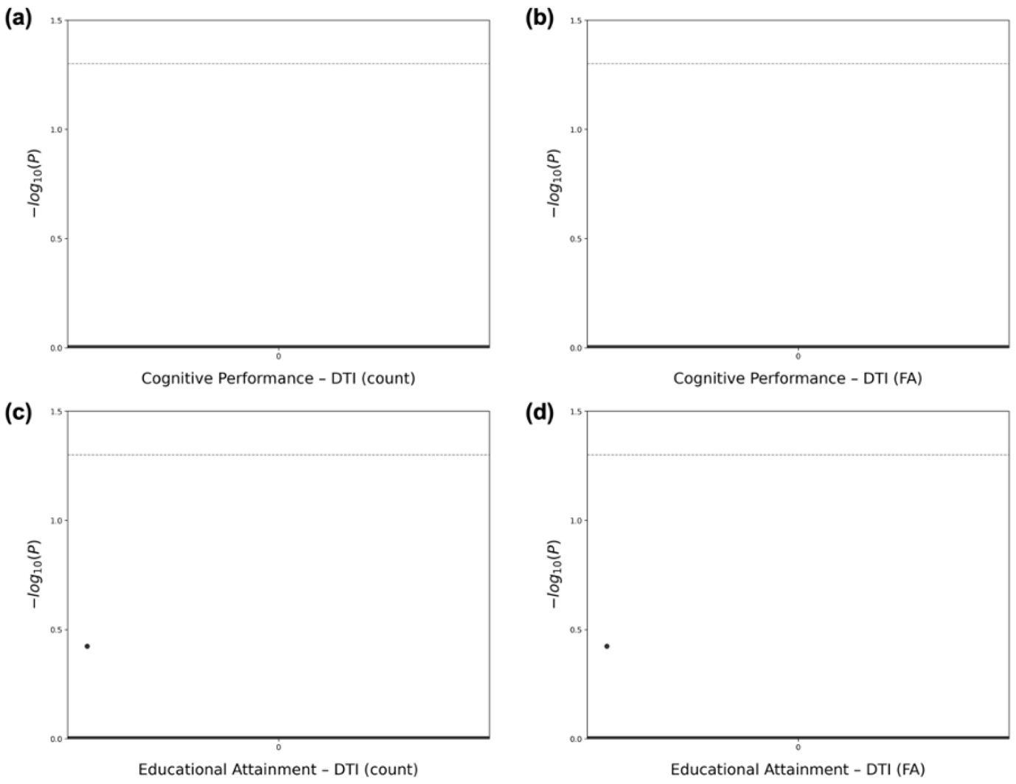

**Supplementary Figure 3. Proportion of explained variances by principal components from cognitive capacity GPSs-related brain morphometric features.**

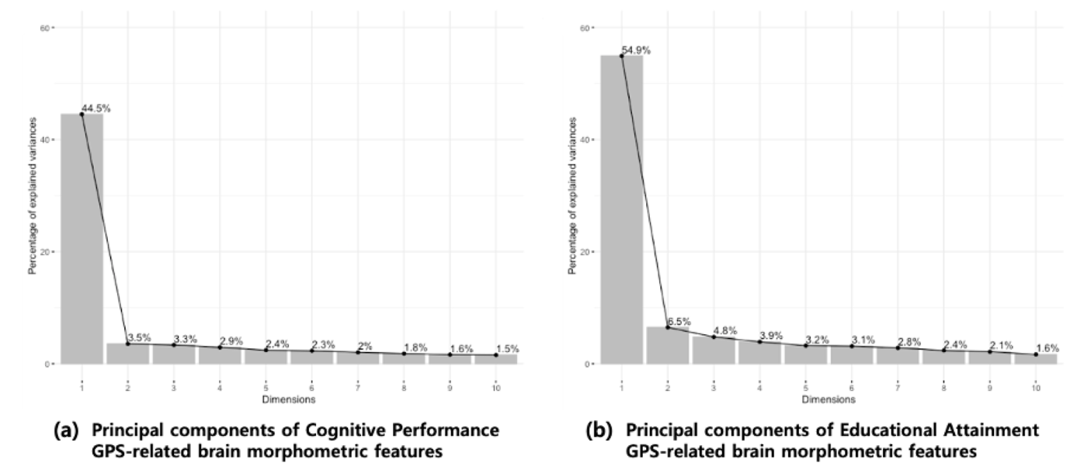

**Supplementary Figure 4. PCA biplot of cognitive capacity GPSs-related brain morphometric features regarding covariates.**

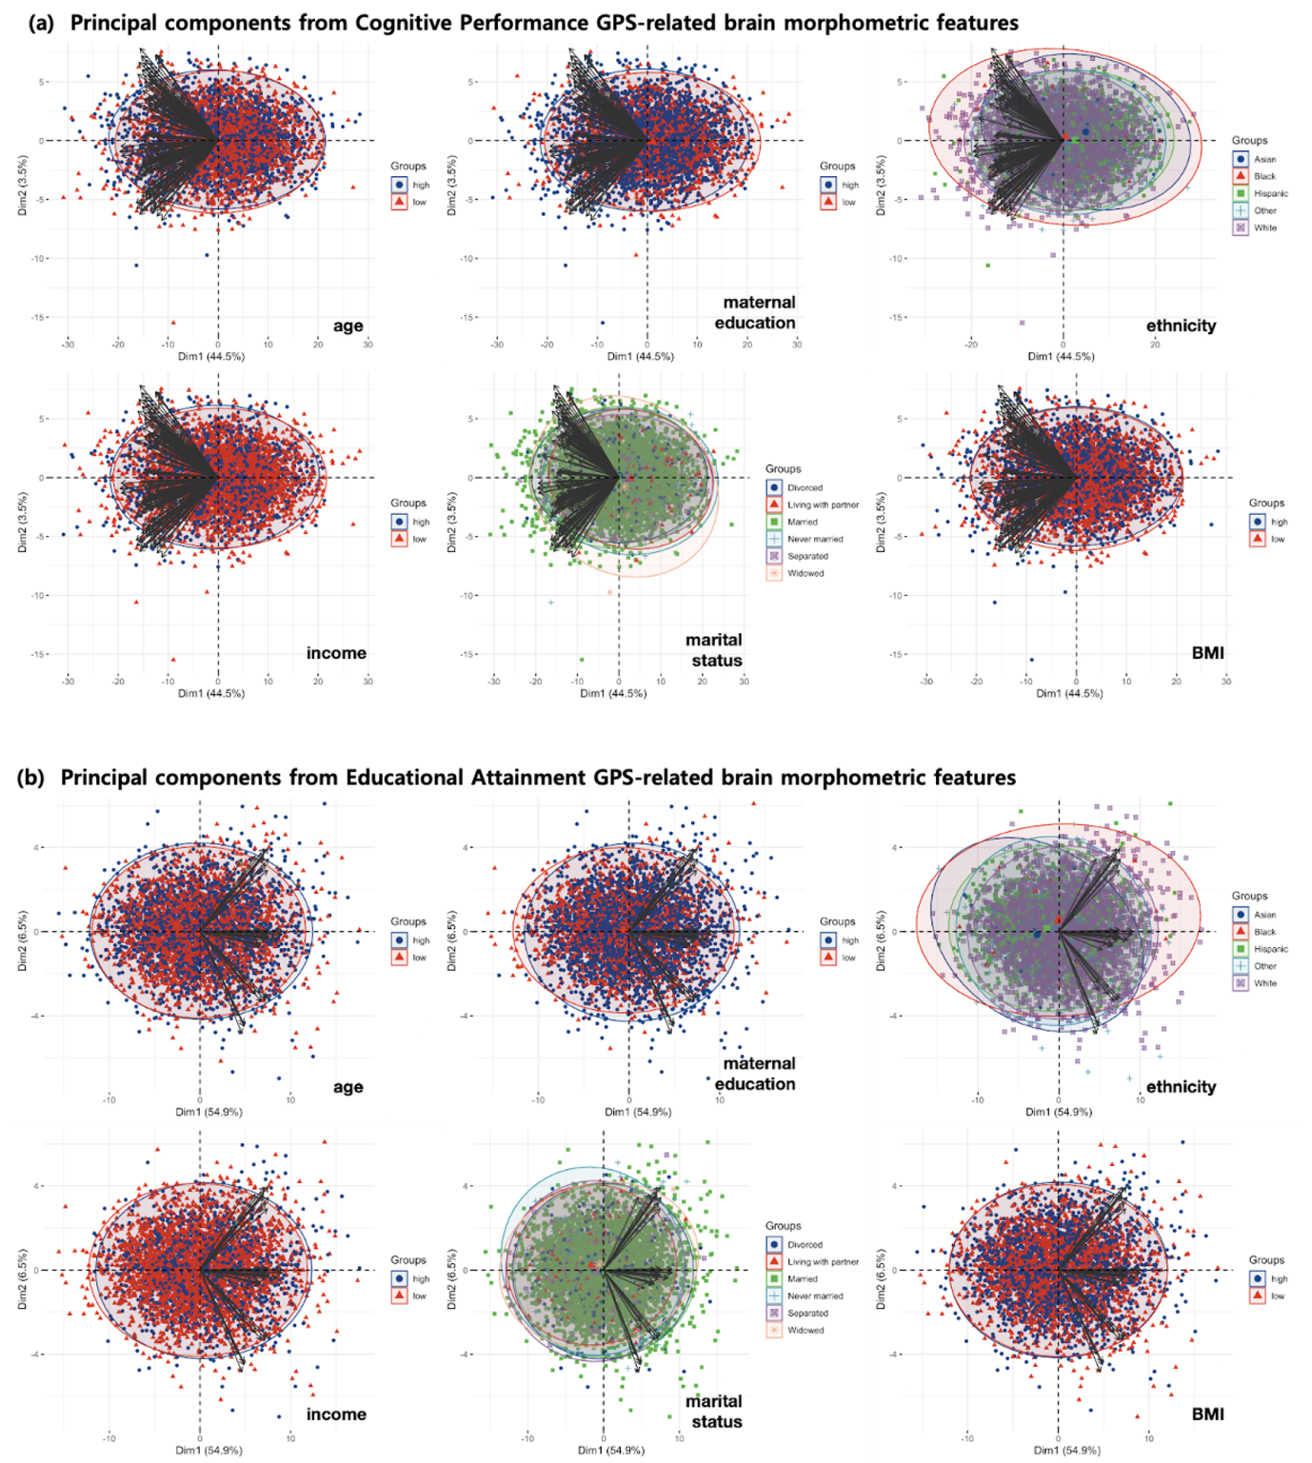

**Supplementary Figure 5.** **PCA biplot of cognitive capacity GPSs-related brain morphometric features regarding sex.** The p-values from the Welch t-test were below 2.2e-16 both in BrainCP GPS and BrainEA GPS.

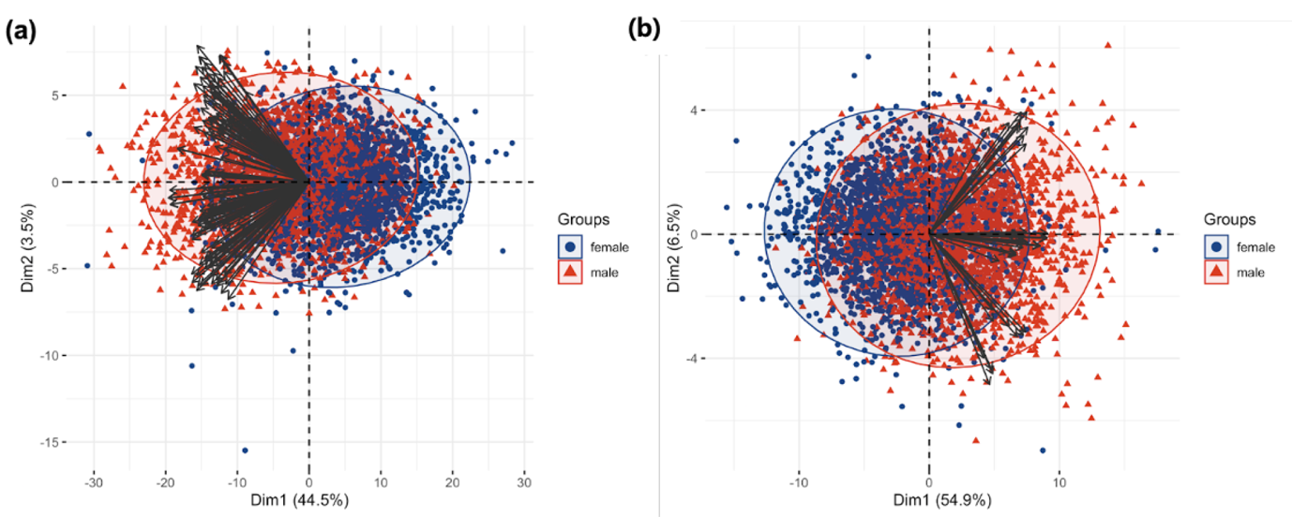

**Supplementary Figure 6. Educational Attainment GPS shows resilient effect on the relationship between abuse and behavior problemsr.** Children with high educational attainment GPS show less A) internalizing behavior problems and B) total behavior problems than children with low educational attainment GPS.



**Supplementary Figure 7. Intelligence shows resilient effect on the relationship between abuse and behavioral problems.** Children with high total intelligence scores show less A) internalizing behavior problems, B) externalizing behavior problems and C) total behavior problems than children with low total intelligence scores.



**Supplementary Figure 8. Educational Attainment GPS shows resilient effect on the relationship between abuse and behavioral problems.** Children with high EA GPS show total behavior problems than children with low EA GPS. Protective effect of EA GPS on the relationship between abuse and behavioral problems were significant even when adjusted for an interaction of total intelligence scores and abuse.

